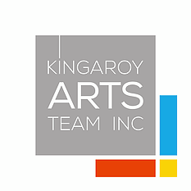
Calendar Kingaroy Regional Art Gallery 2020
January 13 –February 26. Kingaroy Arts Team ( KAT) Members Summer Show.
March -South Burnett Regional Council Art Collection. A showcase of selected items –recent purchases/special collections. Highlighting David Bryce.
April 7th –May 22nd – The David Bryce Art Award. An exhibition of competition entries – information available at www.kingaroyart.com.au
June /July Queensland Winter Craft Festival – the gallery hosts throughout the two months exhibitions, demonstrations, workshops –learn, explore, have fun and celebrate the art of craft.
August a touring Exhibition “Cover Story” Cover Story features the original posters designs and directory cover art commissioned by the Qld Arts Council over a period of about 25 years.. Many of these still operate The Qld Arts Council’s productions and exhibitions reached audiences across the state, with much of the audience consisting of school students. In short, this exhibition will have strong appeal in regional Queensland
September- Niketa Law Recent works. Following on from her highly successful exhibition “Yungi-First Collection” in 2109
October -Kingaroy High - Senior School showcase their works for 2020.
November Jumping Ant Arts A mixed media show by members, which highlights the extraordinary diversity of arts practice within the group
December – “Christmas Crackers” with shop 38- a Christmas Pop up shop for everyone.

